Financial Aid Clearance Form

 STOP

PLEASE READ CAREFULLY. Before you can proceed to and of the following: Graduation, Internship, or Externship, you must receive financial aid clearance and return this form to Career Services.

 You will need to obtain 3 personal references with ***different***addresses and phone numbers to complete Exit Loan Counseling (complete the references information below) before you proceed to the website.

 You will need your FSA ID username and FSA ID password. If you can’t remember your ID and password, you can retrieve it at www.fafsa.ed.gov Exit Loan Counseling typically takes 30-40 minutes to complete. You must complete exit counseling at www.studentloans.gov before coming to financial aid. Remember to select **Community Care College** as your school. If you have previous student loans, we recommend you include those schools as well, for a more accurate obligation/repayment statement. Please let financial aid know if you are experiencing difficulty accessing this site.

 If you **did not** borrow federal student loans, you must still bring this form to the financial aid office to receive clearance.

**STUDENT NAME: ID #:**

|  |
| --- |
| **Reference 1:** |
| Name: Address:  Phone Number: |
| **Reference 2:** |
| Name:  Phone Number:  Address: |
| **Reference 3:** |
| Address:  Name:  Phone Number: |

**Financial Aid Signature / Date**

FA suggests student should start internship/ externship:

1. Log onto www.studentloans.gov

* using your FSA username and password

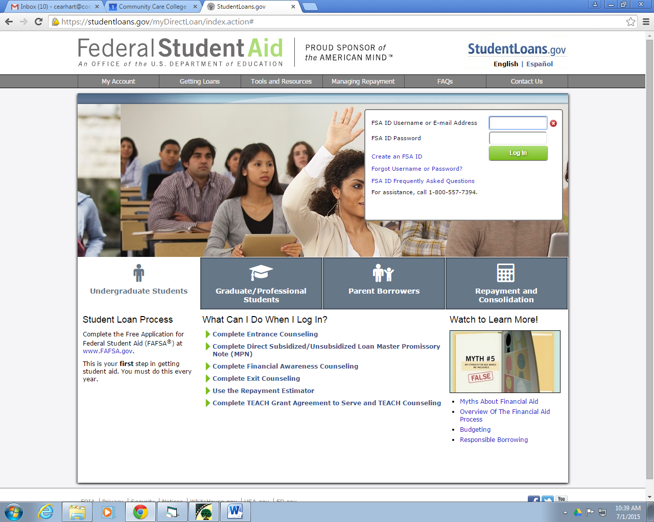

1. Click “Complete Counseling”

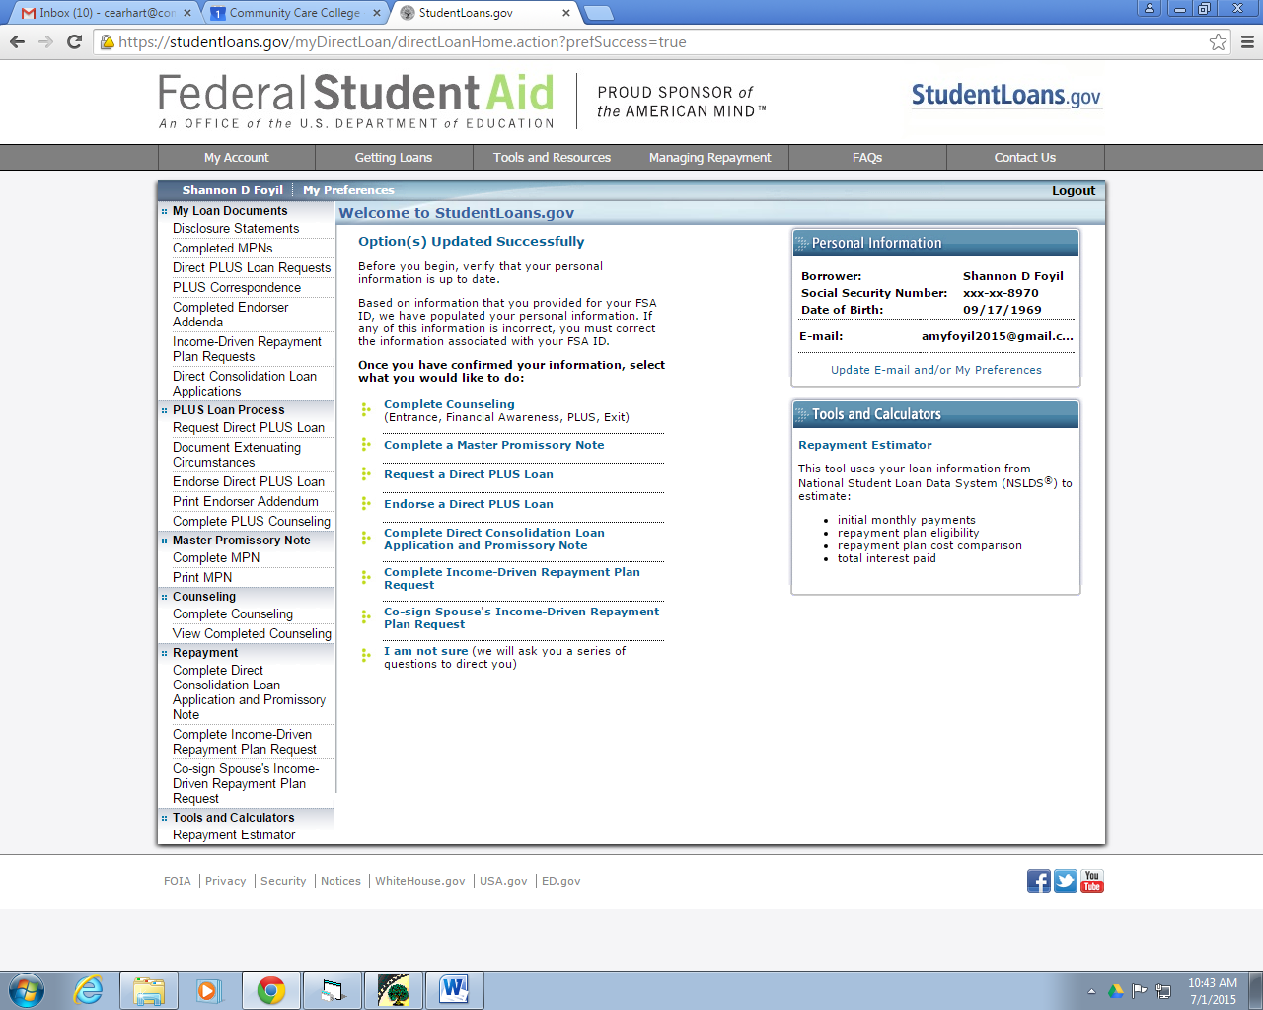

1. Scroll down to “Exit Counseling” then click “Start Exit Counseling”

